Ideation Phase
Define the Problem Statements

Date | 30 June 2025
Team ID | LTVIP2026TMIDS24294
Project Name | BOOKNEST-WHERE STORIES NESTLE
Maximum Marks | 2 Marks

Customer Problem Statement Template:
Problem  Statement (PS) | I am  (Customer) | I’m trying to | But | Because | Which makes me feel
PS-1 | A student who loves reading | Find affordable and interesting books | Most platforms are expensive or limited | They focus on popular titles or charge high | Frustrated and left out
PS-2 | A small seller or book reseller | Sell used or rare books online | Big platforms charge high commissions | I don’t have access to large marketplaces | Disheartened and demotivated
Create a problem statement to understand your customer's point of view. The Customer Problem Statement template helps you focus on what matters to create experiences people will love.
A well-articulated customer problem statement allows you and your team to find the ideal solution for the challenges your customers face. Throughout the process, you’ll also be able to empathize with your customers, which helps you better understand how they perceive your product or service.

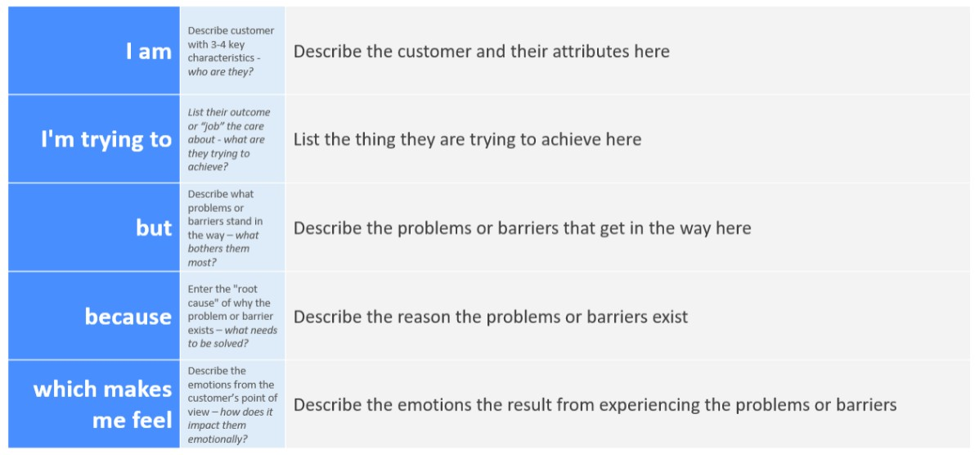
Reference: https://miro.com/templates/customer-problem-statement/
Example:
